

**Passive Filters 설계**



**Frequency Responses of Ideal Filters**

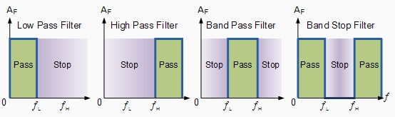

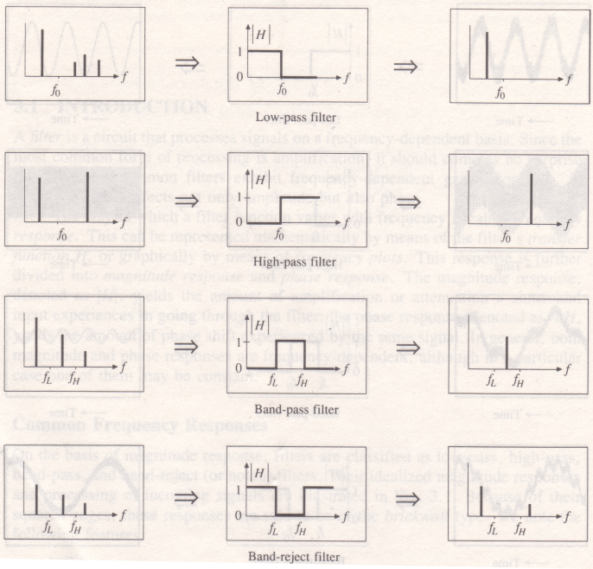

**Filter Functions in Time Domain**

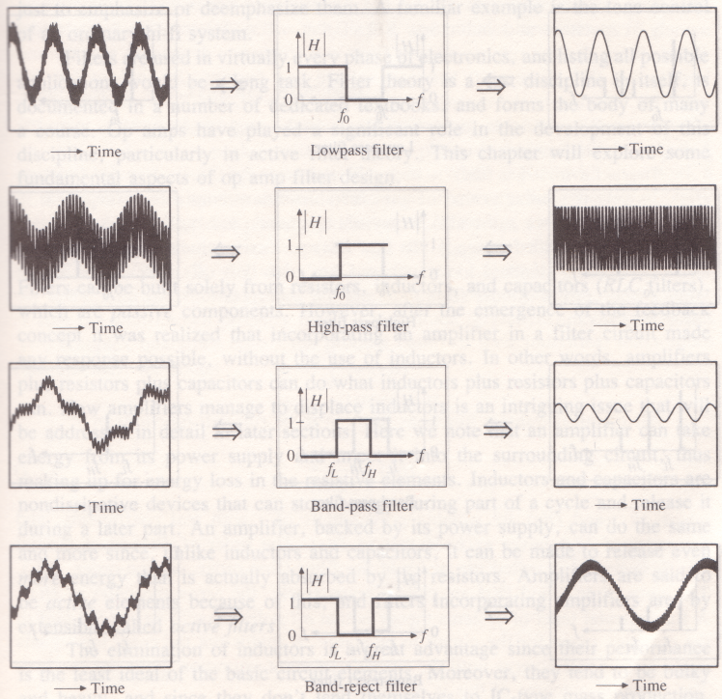

**Frequency Responses of Real Filters**

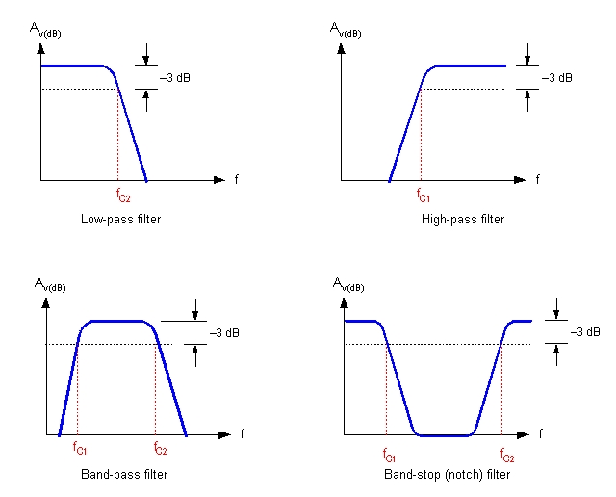

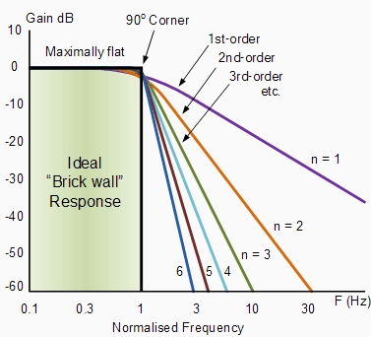

**Butterworth Polynomial**

|  |  |  |  |  |  |
| --- | --- | --- | --- | --- | --- |
| **n** | **b0** | **b1** | **b2** | **b3** | **b4** |
| **1** | **1.00000** |  |  |  |  |
| **2** | **1.00000** | **1.41421** |  |  |  |
| **3** | **1.00000** | **2.00000** | **2.00000** |  |  |
| **4** | **1.00000** | **2.61313** | **3.41421** | **2.61313** |  |
| **5** | **1.00000** | **3.23607** | **5.23607** | **5.23607** | **3.23607** |

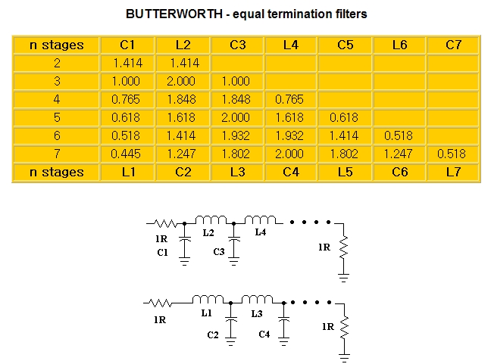

**Normalized Low pass to Denormalized Low pass**







**Elements exchange**



--------------------------------------------------------------------------------------------------------------



**Normalized Low pass to Normalized High Pass**







**Elements Exchange**



--------------------------------------------------------------------------------------------------------------



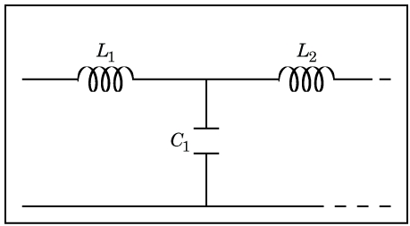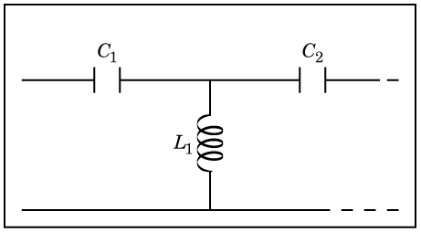

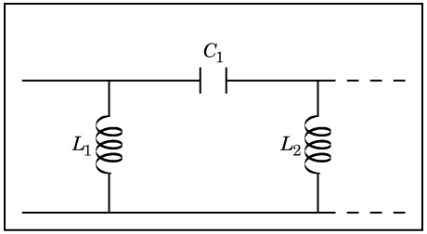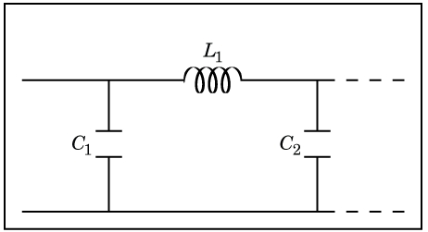

**Normalized Low pass to Normalized Band Pass**









* *ωo*: center freq.
* BW(B) : Bandwidth
* Quality factor, Q



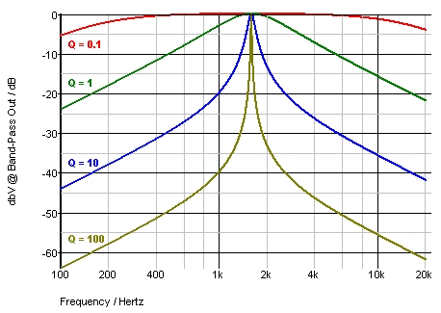

**Elements Exchange**















--------------------------------------------------------------------------------------------------------------











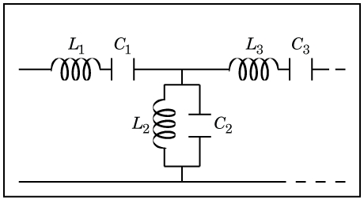

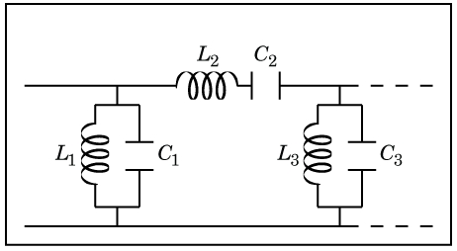

**Normalized Low pass to Normalized Band Stop**









* *ωo*: center freq.
* BW(B) : Bandwidth
* Quality factor, Q



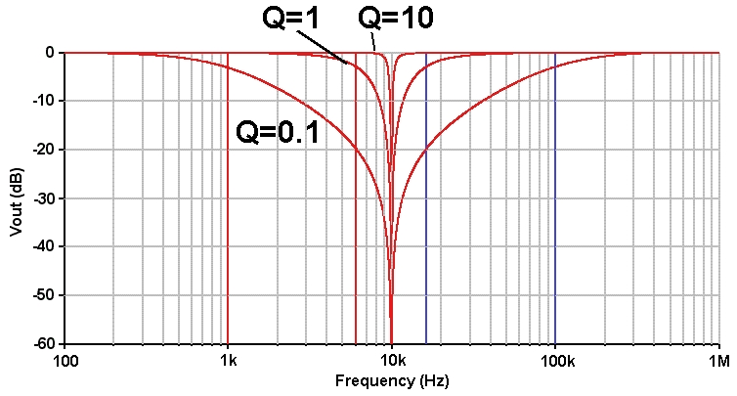

**Elements Exchange**











--------------------------------------------------------------------------------------------------------------













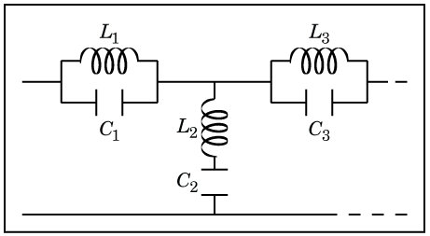

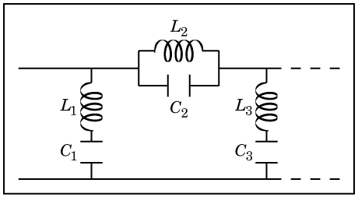

**Impedance Scaling**

 

 

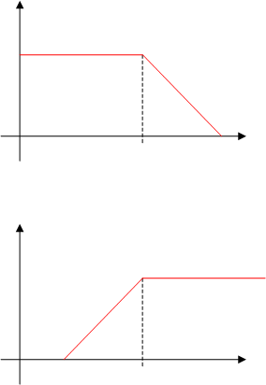**Frequency Scaling**



**Desired reference frequency ; ,**

**(Denormalized)**

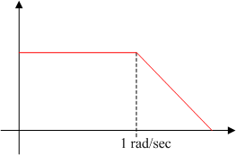

**Existing reference frequency**

**(Normalized)**

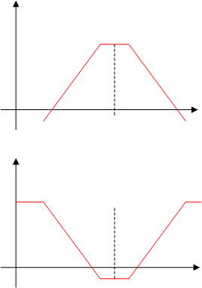



**Impedance and Frequency Scaling**

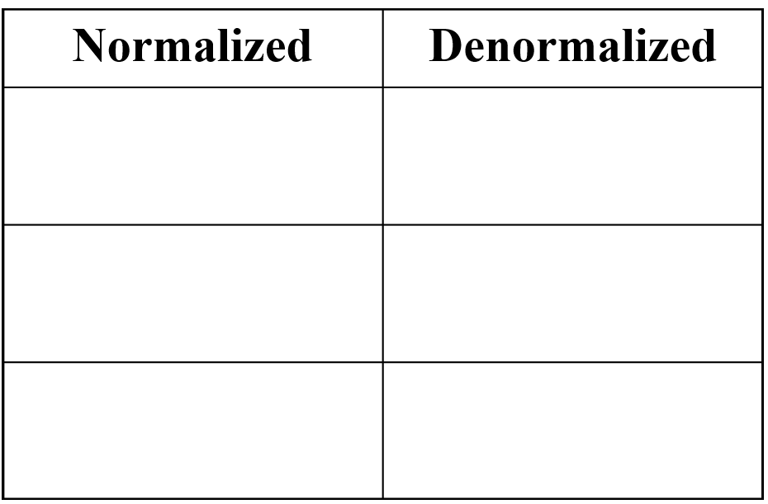











**(Design Problem)**

* Design a 6th-order Band Pass Filter with
  + Center frequency of ωo = 100,000 rad/sec
  + Quality factor of Q = 10
  + Using resistance = 1kΩ



**(Example) 3-way Speaker System**

